Hands on 3:

OUTPUT- REST - Country Web Service

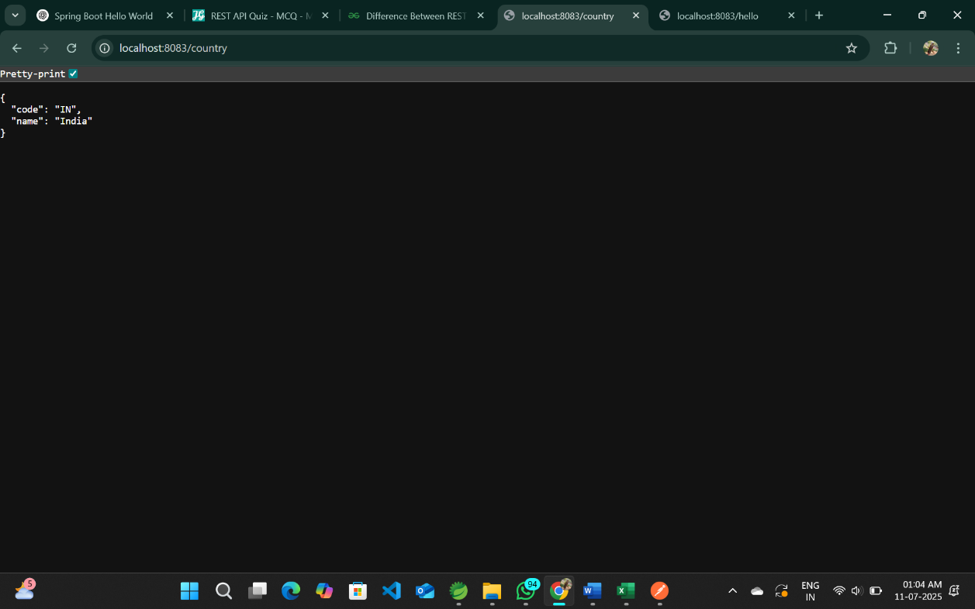

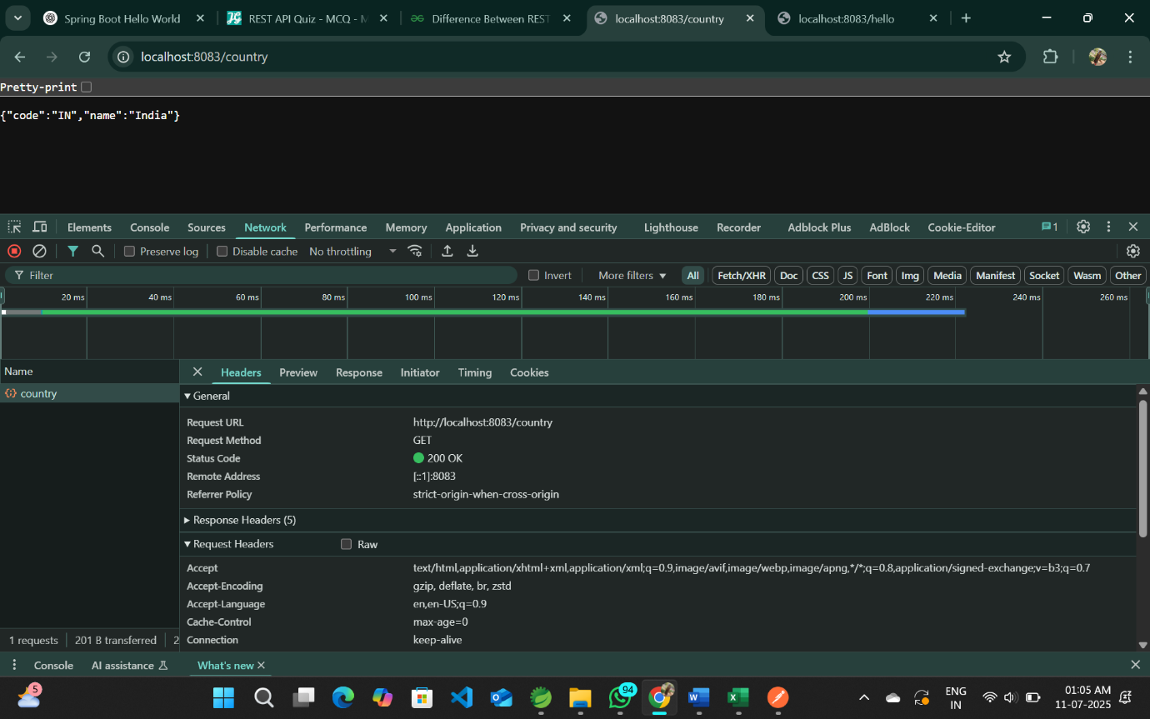

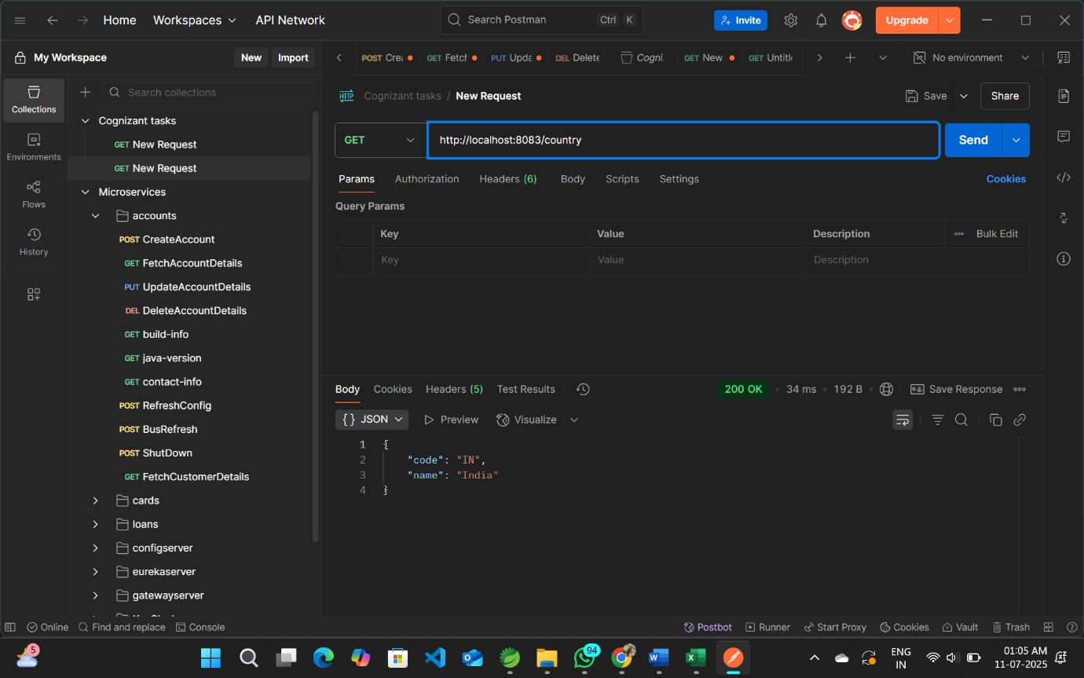

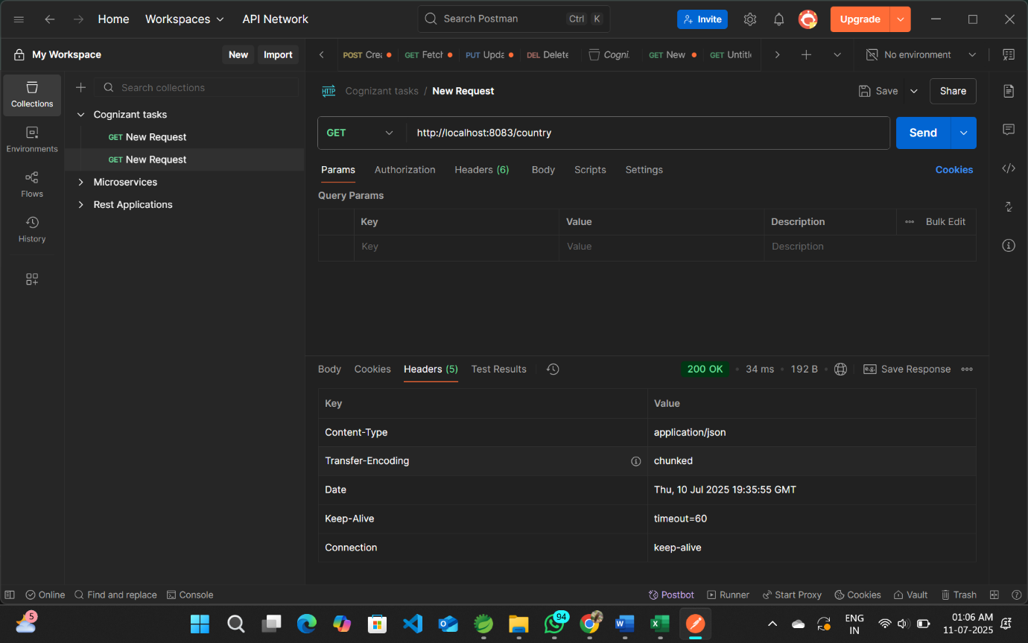

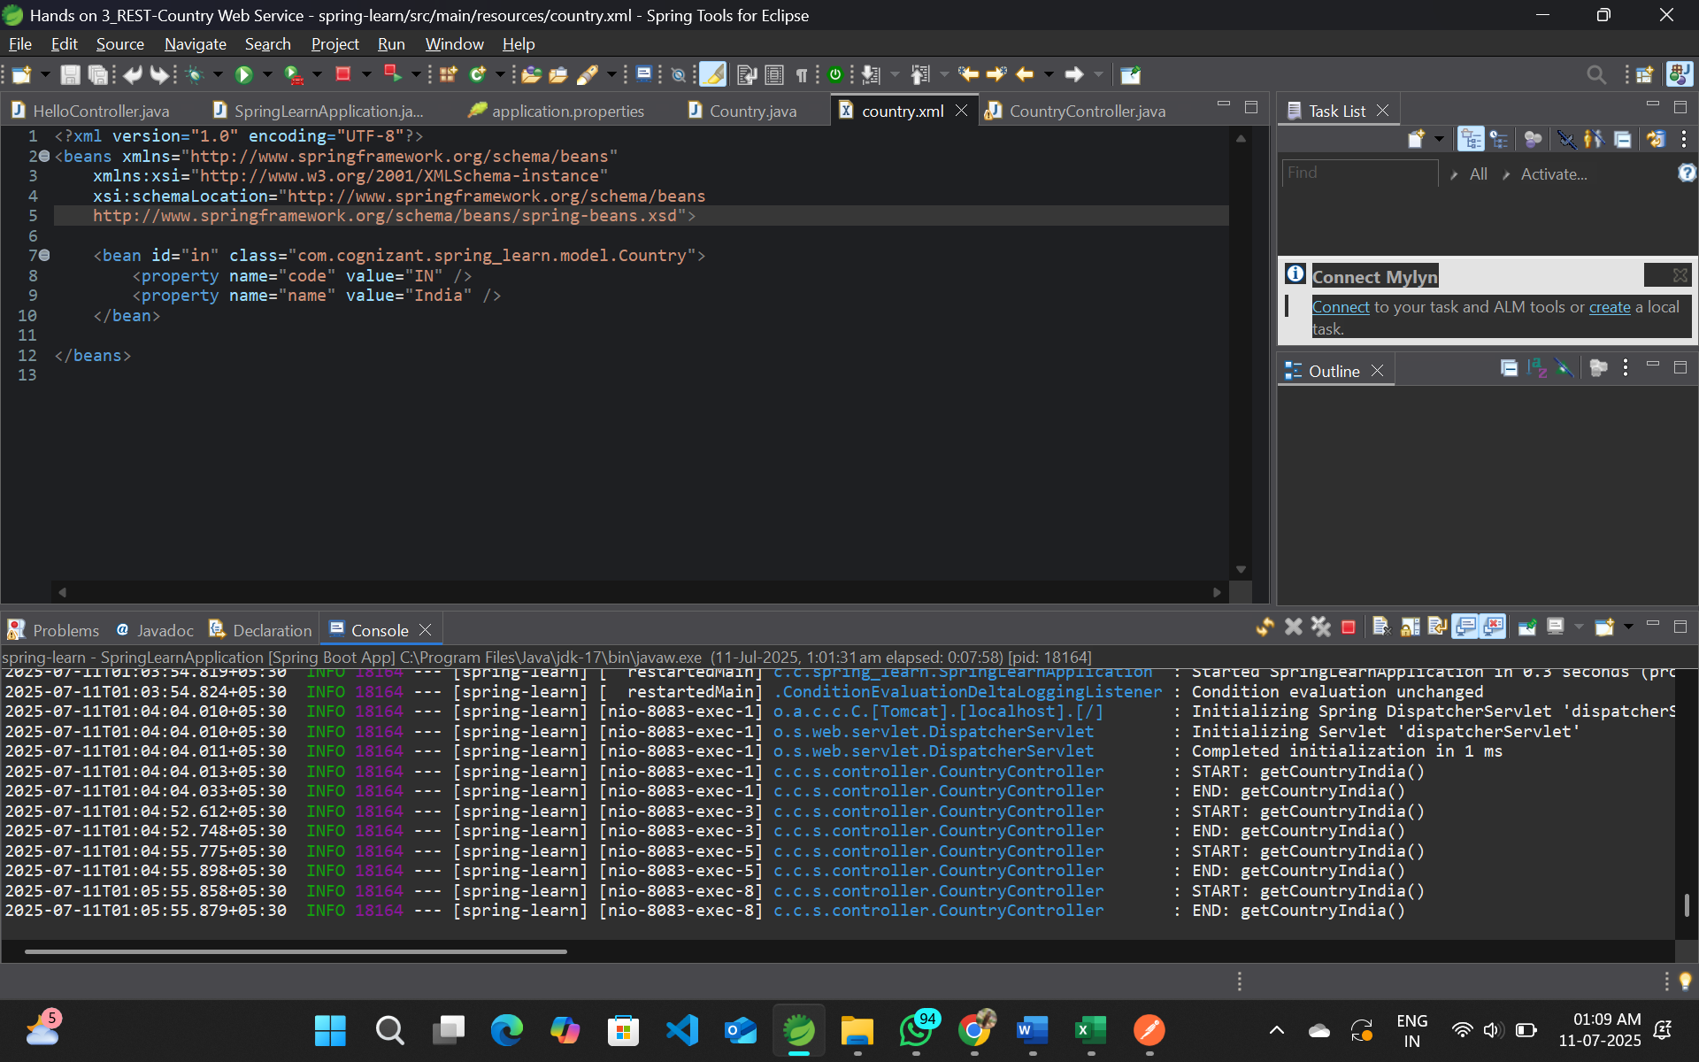

**Explanation for /country REST API**

**1. What happens in the controller method?**

In the controller method getCountryIndia(), the following steps occur:

* When a GET request is made to http://localhost:8083/country, Spring maps it to the method getCountryIndia() using the @RequestMapping("/country") annotation.
* Inside the method, a new ApplicationContext is created using ClassPathXmlApplicationContext, which loads the XML configuration file country.xml from the resources folder.
* The bean with ID in is fetched from the Spring container and cast to a Country object.
* Logging is done at the start and end of the method using SLF4J.
* Finally, the Country object is returned to the client as a response.

**2. How the bean is converted into JSON response?**

Spring Boot uses the **Jackson library** internally to automatically convert Java objects to JSON format. Here's how it works:

* The controller is annotated with @RestController, which combines @Controller and @ResponseBody. This tells Spring to directly write the return value into the HTTP response body.
* When the Country object is returned from the method, Spring Boot uses **Jackson** to serialize it into JSON.
* Since Jackson is included by default in Spring Boot, no additional configuration is required.
* The resulting JSON looks like:

{

"code": "IN",

"name": "India"

}

**3. In network tab of developer tools show the HTTP header details received**

To view HTTP headers in Chrome:

1. Open Chrome browser.
2. Press F12 to open Developer Tools.
3. Go to the **Network** tab.
4. Visit: http://localhost:8083/country
5. Click on the /country request in the list.

You will see the following **Response Headers**:

* **Content-Type**: application/json
  + Indicates that the response body is JSON.
* **Content-Length**: 31 (may vary depending on spacing/formatting)
  + The length of the response body in bytes.
* **Date**: The date and time the response was sent.
* **Connection**: keep-alive
  + Suggests the server can keep the TCP connection open for reuse.

**4. In Postman click on "Headers" tab to view the HTTP header details received**

To view headers in Postman:

1. Open Postman and send a GET request to:  
   http://localhost:8083/country
2. Click on the **Headers** tab below the response area.

You will see similar **Response Headers**:

* **Content-Type**: application/json; charset=UTF-8
  + Confirms the response format is JSON.
* **Content-Length**: The size of the response body.
* **Date**: When the server responded.
* **Connection**: keep-alive
  + Indicates that the connection remains open for performance.